Based on our collected responses from our questionnaire, we were able to find some patterns that have emerged from the responses. We can conclude that the majority of our responses, which is around 77%, are from students.

Caleb - **Rationale**

**1 talk about total response, how we cleaned data**

2 analyse patterns

KY

* **Split into how often they hike those who hike (we will use this) & those who do not hike (we won’t be using this)**
* students -> age group majority
* age group majority -> how often they hike
* Those who hike Vs Trail difficulty level, Trail location, Trail distance, Trail amenities (restroom, parking area, etc.) ,Trail reviews from other hikers

Ans

* Experience with app (those who has experience with the app), list down the count each of the limitations **(need to clean the no experience with app data on limitation)**
* Even those who are not injured, still thinks that emergency services are important
* (a graph for this )Topo vs (a graph for this) online map, can put both maps in the app (allows users to switch in between)
* History trail history vs turning on gps

Caleb

* How well is your photography skills vs How often do you like to stop and take photos during a hike (it doesn’t matter how well their skills are, they still stop and and take pics while hiking)
* hiking photography tips and tutorials vs photography skills
* best photo spots on the hiking trail vs photography skills
* kind of photos/videos vs How often do you like to stop and take photos during a hike

ZX

* (**3 - 5**) How engaging are you towards an app with community features? (eg. Instagram, Twitter) vs How often do you share your hiking photos on social media? (eg. WhatsApp, Instagram)
* How engaging are you towards an app with community features? (eg. Instagram, Twitter) vs Would you be interested in interacting with other hikers and photographers?
* Age group (looking at the majority age group, should be 18-25) vs user profile (describe based on 18-25), reward system (rewards to customise profile),
* game play aspect (is balanced) (not a high priority), pay one time (pay for the app features) (not a high priority)

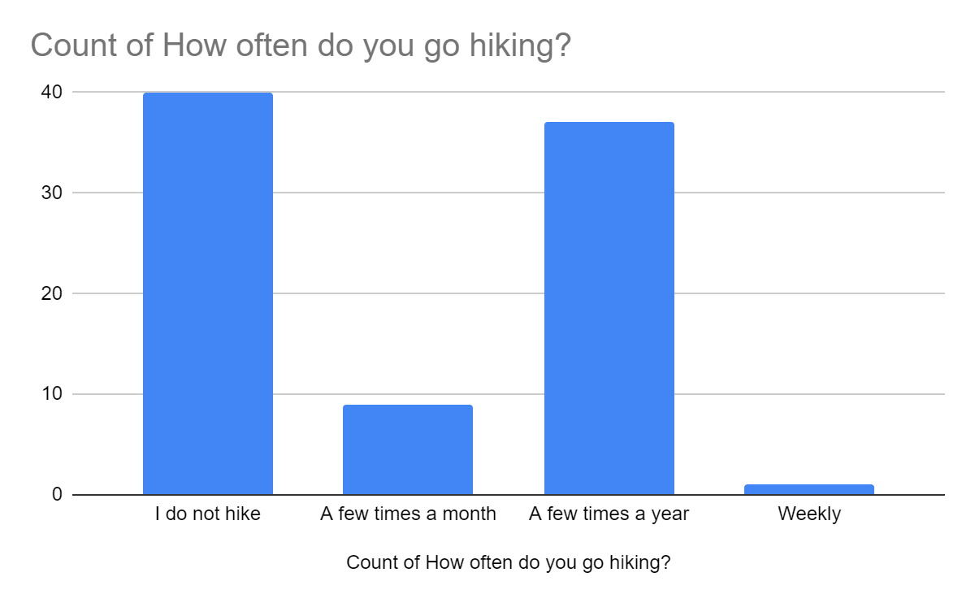

Numbers on top of the bar charts?

Student -> 40, 9, 37, 1

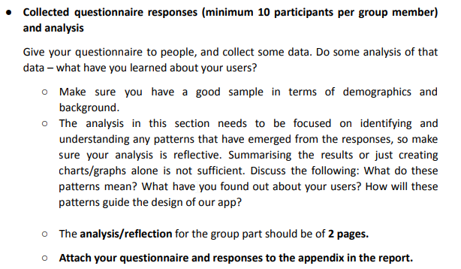

* Majority age group

There's

1. Beginner hikers (don't rly know how to start) (those who don’t know how to read maps, plan a route, emergency services)

2. Community hikers (hike with others, some experience) (group features) (sharing trails) (see where your friends are currently trekking) (like waze)

3. Hiking photographer (like to take photo)

4. Social media interaction (ppl who like to share photos and engage online) (they want virtual reality hike?) VR? (like instagram) (Share trail reviews)

2 is more of like, social during hiking, so they can add features for them to group up w friends or look at the map and hike w others but not necessarily interact online a lot (doesn’t relate to social media)

4 is more of the community features, what they expect (relates to social media, sharing, photo all those)

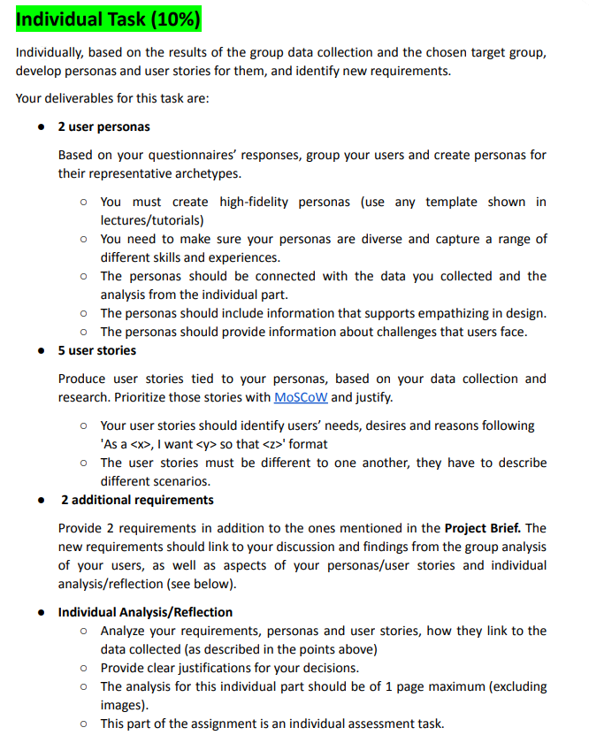

~~Based on the responses from our questionnaire, the majority of the respondents are students who fall between 18 to 25 years old. We can observe that most of the respondents between the ages of 18 and 25 do not hike frequently. Specifically, 46 out of 112 respondents do not hike, which represents approximately 41% of the sample. Additionally, 42 out of 112 respondents hike a few times in a year, which represents approximately 38% of the sample. Only 11 out of 112 respondents hike weekly or a few times in a month, which represents approximately 10% of the sample. This suggests that a significant portion of the 18 to 25-year-old respondents do not hike at all or hike frequently, while a smaller portion participate in the activity on a more regular basis.~~

**Analysis based on beginner hikers**

Based on the responses from our questionnaire, the majority of the respondents are students who fall between 18 to 25 years old. We can observe that most of the respondents between the ages of 18 and 25 do not hike frequently. From our analysis, 46% of the respondents do not hike and 42% of the respondents hike a few times in a year, about 11% of the respondents hike weekly or a few times in a month. This suggests that a significant portion of the 18 - 25 years old respondents do not hike at all or hike less frequently, while a smaller portion participate in the activity on a more regular basis.

For those who hike, most of them ranked the trail difficulties, trail location and trail distance as either 3, 4 or 5 on a scale of 5. On the other hand, they ranked the trail amenities and trail reviews as average importance which is either 2 or 3. Hence, this shows that most of them consider the trail difficulty level, trail locations and trail distances are more important than the trail amenities and trail reviews. This does make sense since most of our respondents are novice hikers, hence the difficulty level can help them determine if it suits their fitness level and skill set. They might also want to choose a trail that is close to home or easily accessible, so they don't have to spend a lot of time travelling to the trailhead. The trail distance also seems to be important as they may not want to challenge themselves on a long trail due to their lower endurance level and lack of experience. Therefore, a hiking app that allows the user to choose their trail based on their required trail difficulty and distance would be a great option to cater to their hiking needs. Hence, for beginner hikers, these three factors are able to ensure their safety, enjoyment, and overall experience on the trail.

**Analysis based on casual hikers**

Our survey results demonstrate that the majority of respondents find hiking trail apps useful, with only five out of 112 disagreeing. The top three limitations of such apps are outdated information, lack of detailed maps, and limited community engagement. Using these findings, we plan to develop an app that addresses these key limitations, while also including emergency services, as identified as a necessary feature by our analysis. We also learned that most users prefer online maps over topographic maps, which we will include as an option in our app. Additionally, our analysis of the trade-off between GPS tracing and trail history preservation revealed that most users who want to save their hiking trails are comfortable with GPS tracking. As a result, we will implement a feature to save users' hiking trails using GPS, which will provide greater accuracy.

**Analysis based on community features**

According to our observation towards the collected data, the majority of the respondents are mostly engaging towards community features, however, this contradicts the fact that the majority of the respondents does not share their hiking photos specifically on social media. This might be due to the fact that most of the respondents do not think that the usual social media apps such as Instagram, Twitter, Facebook etc is a suitable platform to share their hiking photos. A platform that is specifically made for sharing their hiking photos would be a suitable choice for these respondents as they have a more comfortable sharing platform for others with a similar interest in hiking. Besides that, about 72% of the respondents who are more engaging towards social media are more willing to interact with other hikers and photographers. This might be because they are more social in general, and therefore more likely to seek out social interaction towards other hikers and photographers. A platform that is specifically made for hikers and photographers with community features would be an excellent platform for them to reach out to others with similar interests. Also, about 88% of our respondents are within the age group of 18-25 years old. This correlates to the fact that most of our respondents are young adults who are students. According to the observed data, 73% of these respondents are more interested in seeing a user profile customization feature in the hiking app . This might be due to the fact that a user profile would be a good way for the users to express themselves in terms of their customization of their user profile. Around 77% of our respondents who are within the age group of 18-25 years old are also more likely to be interested in seeing a reward system within a hiking app that grants users points after completing a certain task. This might be due to the fact that these respondents who are tech savvy, are familiar with these kinds of rewards systems that are implemented in other apps as well. These reward systems could motivate the users to continue using the app by giving them a sense of accomplishment and encourage them to continue using the app. The overall responses towards the gameplay aspects in a hiking app were uniformly distributed. However, around 76% of the respondents are still interested in seeing some gameplay aspects in a hiking app. This might be due to the fact that most of the respondents are tech savvy young adults who enjoy these features in an app. Based on the collected data, most of the respondents are not interested in a one-time payment to unlock app features. This might be due to the fact that the majority of our respondents are students and therefore do not have the financial ability to have in-app purchases unless they think it is necessary.

**Analysis based on hikers with photography skills**

For our respondents’ photography skills, on a scale of 1 to 5, we found that 50% of our respondents gave their photography skills a score of 3, while the scores lesser and greater than 3 were split into a total of 25% each. Furthermore, around 98% of our respondents responded that they use smartphones for their photography, with the rest of respondents responding that they use professional cameras or do not partake in photography activities. From this analysis, we can conclude that most of our respondents are amateur photographers who usually take pictures using smartphones, with only a small minority being experienced with professional photography. Relating to our target age group, this is a sensible conclusion as most students won’t be experienced with professional photography unless it was their hobby or profession. Additionally, some may be able to afford expensive equipment and rely on their smartphones for photography.

For the analysis of the photography app features, we will mostly look at the people who responded themselves with a positive score for photography skills since they are our target audience for photography features. Out of a total of 80 respondents included in the group mentioned above, 67 responded with a positive score when asked if they would stop and take photos while on a hike. This shows that there is a positive relationship between respondent’s photography skills and the frequency of taking photos on a hike, so this target group is suitable for our photography features. When asked if the respondents were interested in hiking photography tips and tutorials and photo spot recommendations, 64 and 77 responded with a positive score respectively. Surprisingly, the respondents who gave a lesser score in their photography skills responded favourably regarding the best photo spot recommendations, with 22 out of 32 responding with a positive score. Through this analysis, we can conclude that the respondents who have more interest in photography are more keen to improve on their skills with the tips and tutorials. In comparison, all respondents in general are very keen on knowing the best photo spot locations. This may be because they still want to enjoy the nice views of nature despite lacking in photography skills or they want the help of others to take some photos of themselves. Therefore, a hiking app that provides the user tips and tutorials on hiking photography as well as recommending great photo spot locations will help cater to the needs of users especially hiking photographers.